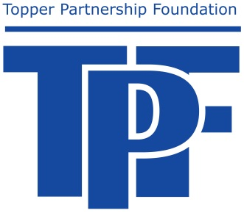
The Topper Partnership Foundation
for the
School District of Glenwood City

Creative Ideas Grant
STUDENT APPLICATION Criteria

Eligibility
A student attending the Glenwood City School District may apply for a grant.

Application Process
- Completely fill out the application. The application form is available from the school district website www.gcsd.k12.wi.us
- You must get signatures from your principal, your teacher, and your parent(s).
- Type your application. Handwritten proposals are difficult to read and will not be accepted.
- Have someone proofread your application.
- Additional pages may be added if needed.

Timeline
- Completed applications may be turned into the District Office.
- Applicants will be notified of funding decisions by letter.

Conclusion of Grant
Part of the application process will be the understanding that if awarded grant money, the applicant will communicate back to the TPF and be willing to be published in communications to promote the project and the Topper Partnership Foundation.

The Topper Partnership Foundation
for the
School District of Glenwood City

Creative Ideas Grant
Student Application Cover Page

Student name: Grade level:

Scholarship amount requested: $

Signature Section

If you are selected to receive grant money, by signing, you are agreeing that you will commit the time needed to follow through with your plans.

Student Signature Date

Staff Signature Date
(A teacher with whom you’ve discussed your project)

Principal Signature Date

Parent Signature (unless student is over 18) Date

RETURN COMPLETED APPLICATION TO THE DISTRICT OFFICE

TPF Student Creative Grant Proposal

Briefly describe your community and/or extra-curricular school involvement:

Please describe your plans for using this grant (be specific and include a timeline of a start date and end date):

Explain how you would share your new learning experience with others:

If you were to receive grant money, outline a plan of how the money would be spent:

